**Course Methods test 2 Year 12**

Student name: ________________ Teacher name: ________________

**Task type: Response**

**Time allowed for this task: ___40________ mins**

**Number of questions: ____8_______**

**Materials required:** Calculator with CAS capability (to be provided by the student)

Standard items: Pens (blue/black preferred), pencils (including coloured), sharpener, correction fluid/tape, eraser, ruler, highlighters

Special items: Drawing instruments, templates, notes on one unfolded sheet of   
A4 paper, and up to three calculators approved for use in the WACE examinations

**Marks available: ___41___ marks**

**Task weighting: _10___%**

**Formula sheet provided: Yes**

**Note: All part questions worth more than 2 marks require working to obtain full marks.**

Q1 ( 3 & 3 = 6 marks) (3.2.9)

Determine  in terms of  for the following. Show all working.

1.  and  when .

|  |
| --- |
| **Solution** |
|  |
| **Specific behaviours** |
| 🗸 anti-diffs terms  🗸 introduces an unknown constant and subs to solve  🗸 states value of constant |

1.  and  when .

|  |
| --- |
| **Solution** |
|  |
| **Specific behaviours** |
| 🗸 anti-diffs terms  🗸 introduces an unknown constant and subs to solve  🗸 states value of constant |

Q2 (3 & 2 = 5 marks) (3.2.22, 3.2.5)

A car travels in a straight line from the origin, initially at rest, with constant acceleration with  time in seconds.

1. Determine the distance from the origin at  seconds?

|  |
| --- |
| **Solution** |
|  |
| **Specific behaviours** |
| 🗸 integrates to find v and shows solving for constant with subs  🗸 states the correct rule for x  🗸 states exact value for x at required time, no need for units |

1. What is the velocity of the car at  seconds?

|  |
| --- |
| **Solution** |
|  |
| **Specific behaviours** |
| 🗸 subs into v  🗸 states velocity, no need for units |

Q3 (2 marks) (3.2.19)

Determine the exact area between  and the  axis from  to .

|  |
| --- |
| **Solution** |
|  |
| **Specific behaviours** |
| 🗸 writes a correct integral for the area  🗸 states exact value |

Q4 (2, 2 & 3 = 7 marks) (3.2.18)

A factory produces electric vehicles. The total number, , that the company has produced  months after production commenced is such that:



Determine the number produced in

1. The first 6 months

|  |
| --- |
| **Solution** |
| Number is 2687 vehicles |
| **Specific behaviours** |
| 🗸 writes a correct integral with limits or ant-diff with a constant  🗸 states change, accept decimal |

1. The third month

|  |
| --- |
| **Solution** |
|  |
| **Specific behaviours** |
| 🗸 writes a correct integral with limits or ant-diff with a constant  🗸 states change, accept decimal |

Determine the minimum number of months required to produce:

1. 10000 vehicles.

|  |
| --- |
| **Solution** |
| Need at least 22.27 OR 23 months |
| **Specific behaviours** |
| 🗸 sets up an integral with unknown upper limit  🗸 solves for a decimal number of months  🗸 states number of months |

Q5 (5 & 3 = 8 marks) (3.2.20)

1. On the axes below, sketch the following graphs:  and . Indicate on your sketch coordinates (one decimal place) of any stationary points and label their nature and of any points where the graphs intersect each other.

|  |
| --- |
| **Solution** |
|  |
| **Specific behaviours** |
| 🗸 states coordinates 1dp local max on both graphs  🗸 states coordinates 1 dp local min on cubic (must label min)  🗸 shows that graphs intersect at three points  🗸 states coordinates of 3 points of intersection  🗸sketches correct shape of both graphs  NOTE: follow through does not apply if mistake makes easier! |

1. Determine the exact area between  and .

|  |
| --- |
| **Solution** |
|  |
| **Specific behaviours** |
| 🗸 sets up correct integral(s)  🗸uses correct limits for integrals  🗸 states exact area |

Q6 (2 & 2 = 4 marks) (3.1.3, 3.1.4)

The number of kangaroos,  in a particular site that have developed disease W are increasing such that  with  the time in years. There are initially 2300 kangaroos.

1. Determine the number of kangaroos with disease W in 5 years’ time.

|  |
| --- |
| **Solution** |
| Number of kangaroos 3431 |
| **Specific behaviours** |
| 🗸 uses an exponential function  🗸 states number, accept decimal |

1. Determine the time taken (years in one decimal place) to triple the number with the disease.

|  |
| --- |
| **Solution** |
| Years = 13.7 |
| **Specific behaviours** |
| 🗸 sets up an equation  🗸 states number of years to one decimal place |

Q7 (4 marks) (3.2.16)

Consider the function  such that  and .

Determine the rule for the function .

|  |
| --- |
| **Solution** |
|  |
| **Specific behaviours** |
| 🗸 uses fundamental theorem to express  🗸 integrates to express  in terms of  and a constant  🗸 uses definite integral to set up equation for constant  🗸 solves for constant and express  in terms of x in full. |

Q8 (5 marks) (3.1.15)

Consider the function  where  are constants.

Below is a graph of 

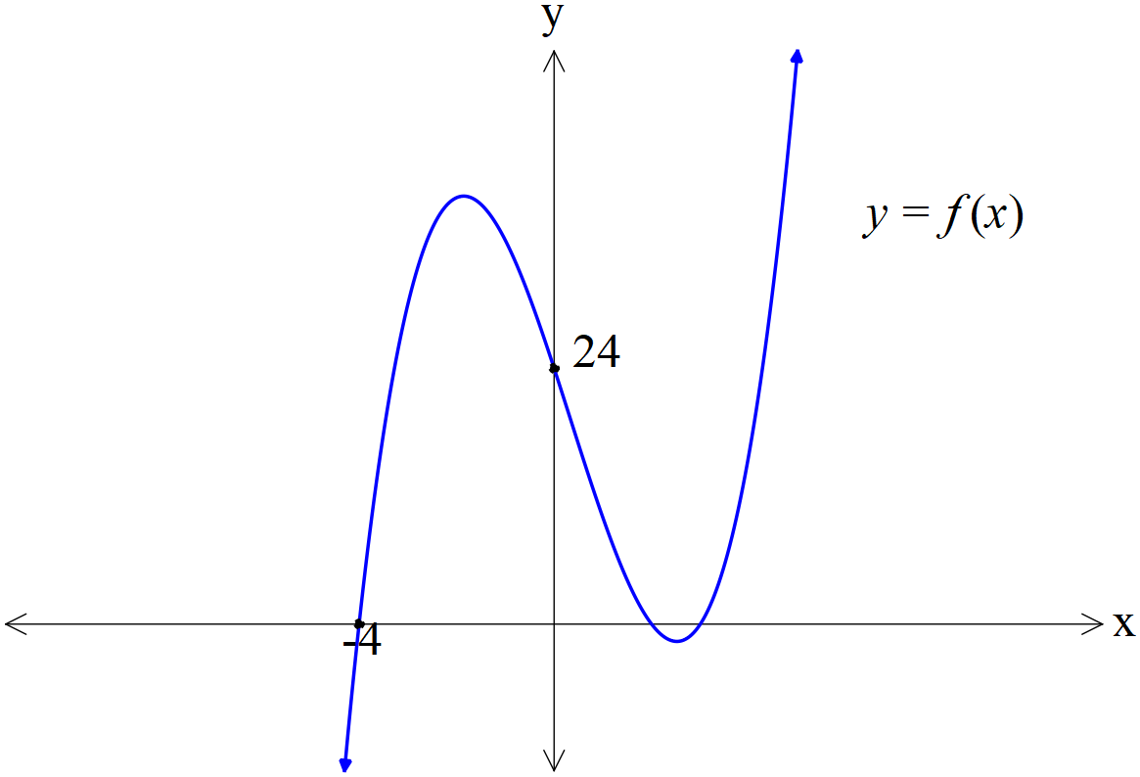

There is an  intercept at ,  intercept at  and .

There is an inflection point at .

Determine the exact values of .

|  |
| --- |
| **Solution** |
| OR solving without classpad  Eq 1 times 2 |
| **Specific behaviours** |
| 🗸 solves for  🗸 derives  using inflection point  🗸 sets up linear equation using x intercept  🗸 uses definite integral and then integrates and sets ups a linear equation for unknowns  🗸states values for all 4 unknowns  NOTE: follow through does not apply if mistake makes easier! |